**OPERATORS**

**Example:**

**Step 1:** Creating a Database

CREATE DATABASE xstream_db;

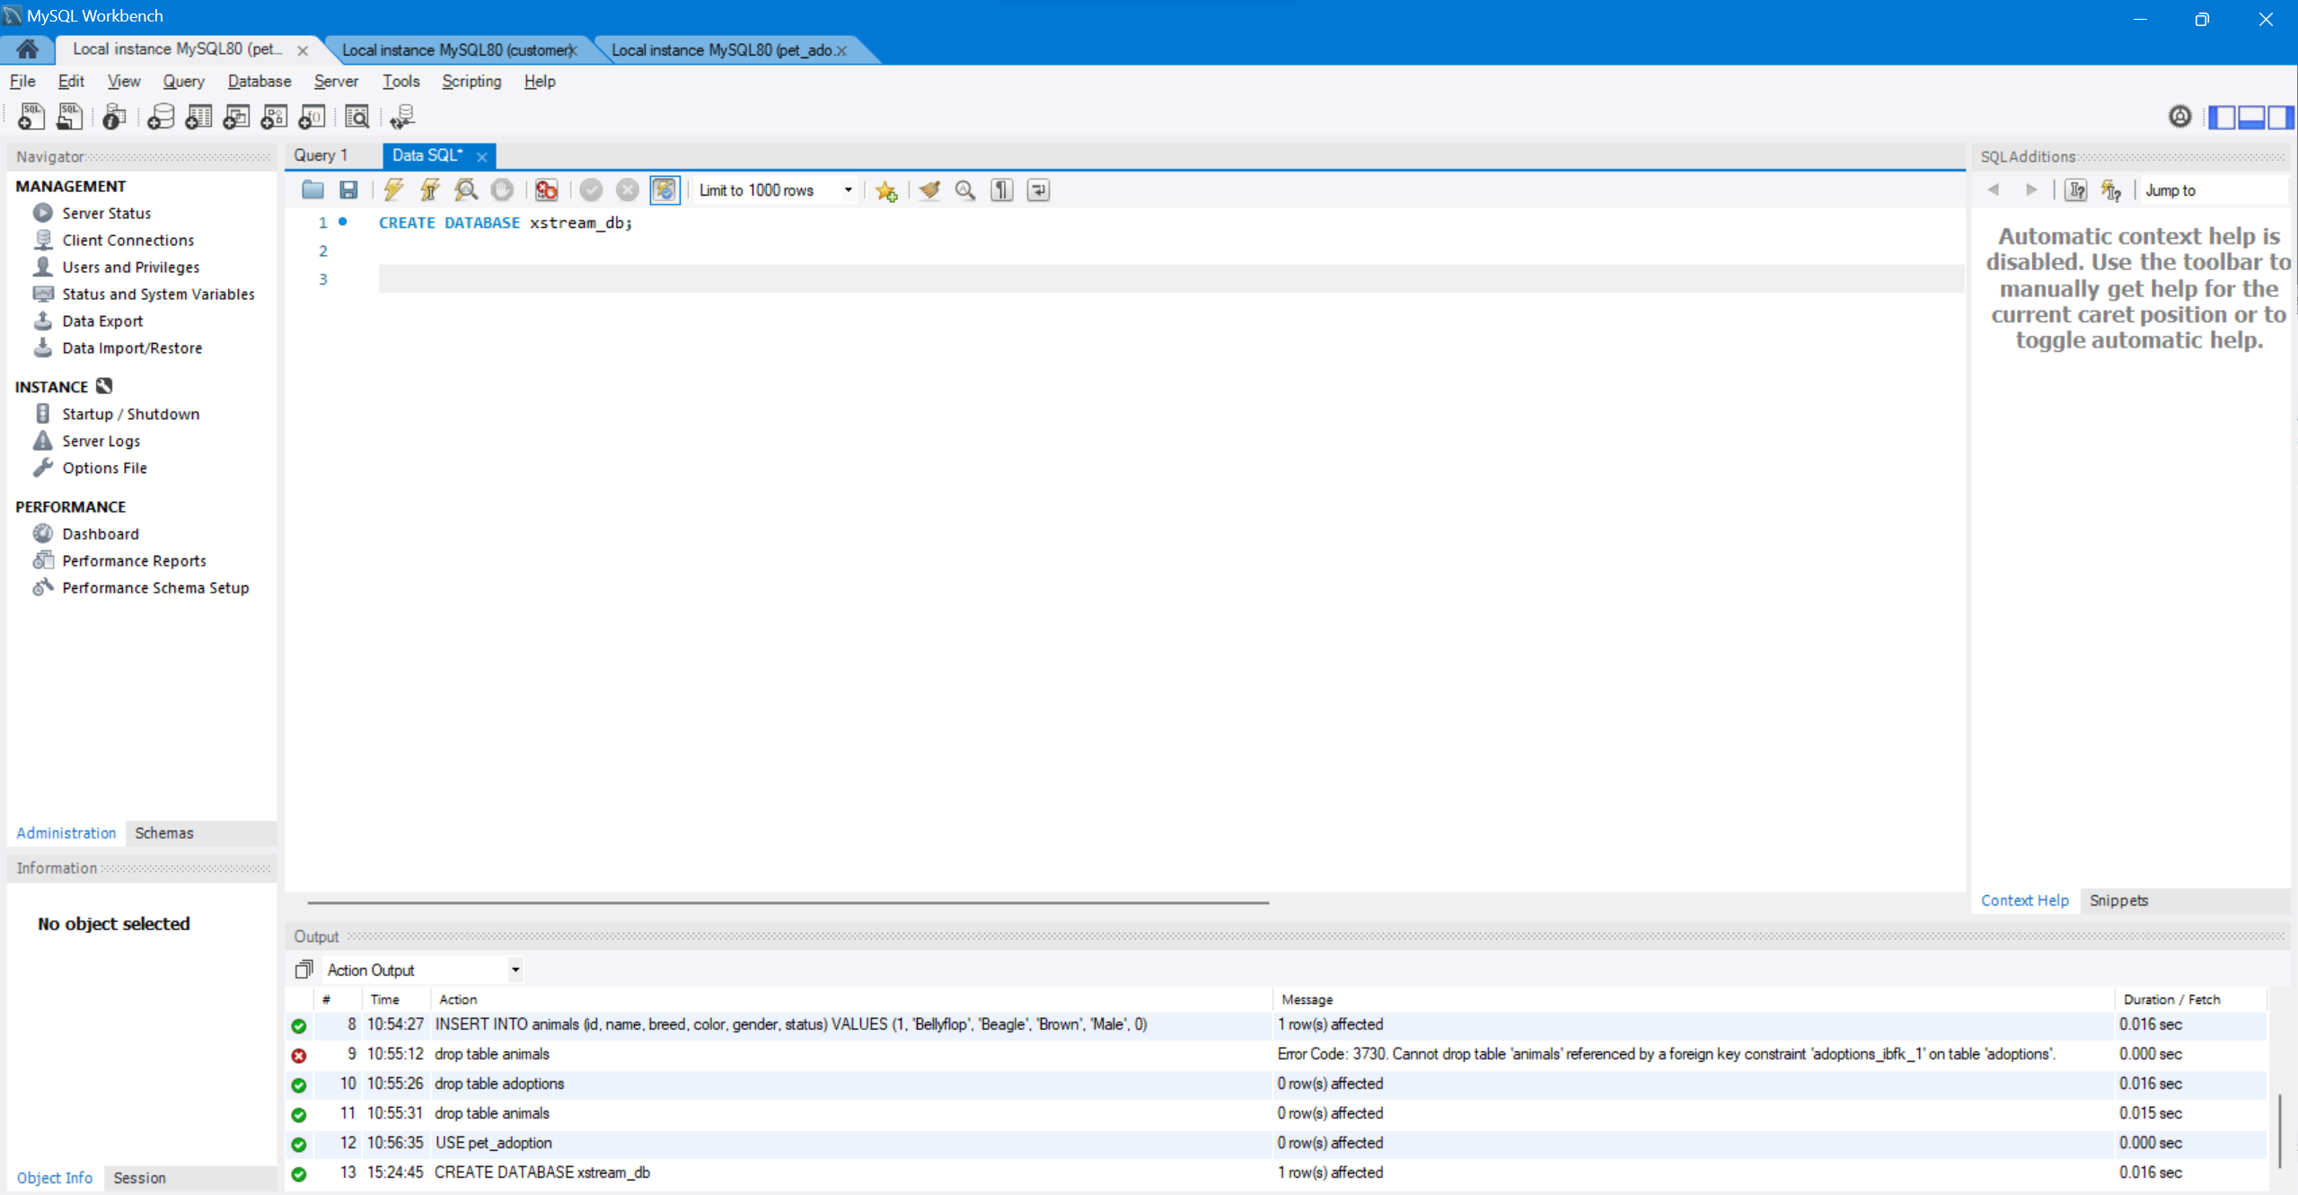

**Step 2:**Create table employee

### ****Query****

CREATE TABLE employee (emp_id INT, emp_name VARCHAR(255),   
 emp_city VARCHAR(255),  
 emp_country VARCHAR(255),  
 PRIMARY KEY (emp_id));

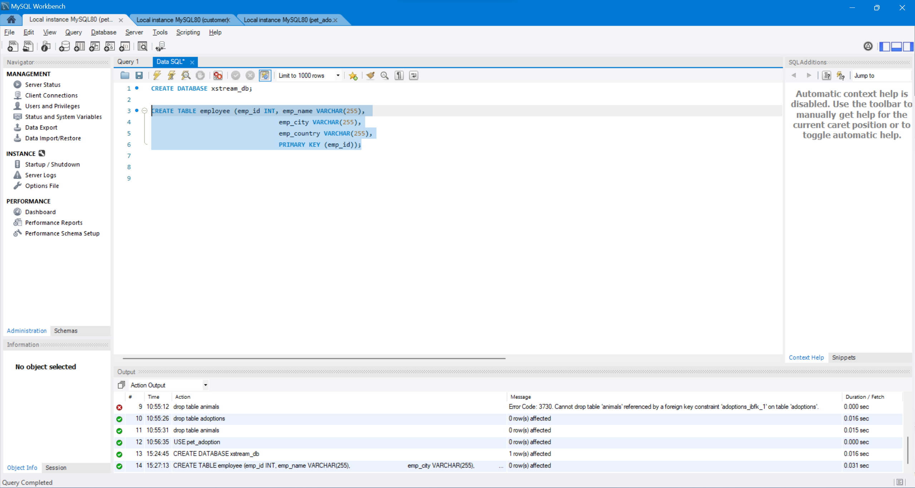

*Create Table*

### ****Query****

INSERT INTO employee VALUES (101, 'Utkarsh Tripathi', 'Varanasi', 'India'),  
 (102, 'Abhinav Singh', 'Varanasi', 'India'),   
 (103, 'Utkarsh Raghuvanshi', 'Varanasi', 'India'),  
 (104, 'Utkarsh Singh', 'Allahabad', 'India'),  
 (105, 'Sudhanshu Yadav', 'Allahabad', 'India'),  
 (106, 'Ashutosh Kumar', 'Patna', 'India');

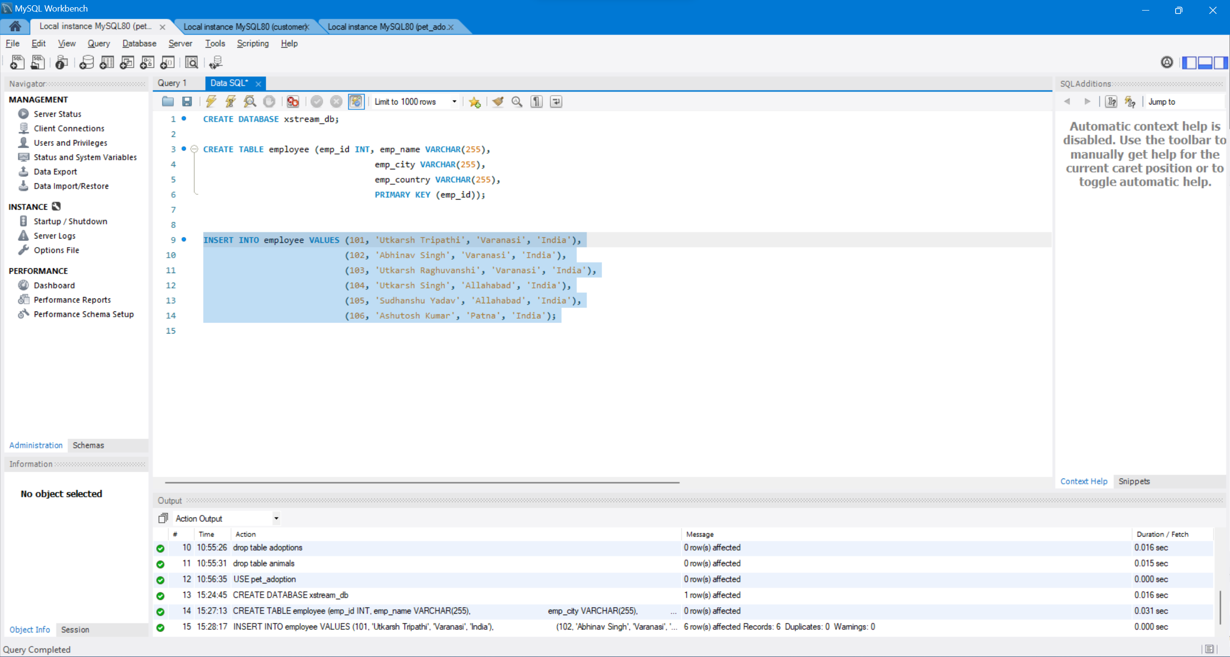

## ****AND Operator****

### ****Query****

SELECT * FROM employee WHERE emp_city = 'Allahabad' AND emp_country = 'India';

### ****Output****

### 

## ****IN Operator****

### ****Query****

SELECT * FROM employee WHERE emp_city IN ('Allahabad', 'Patna');

### ****Output****

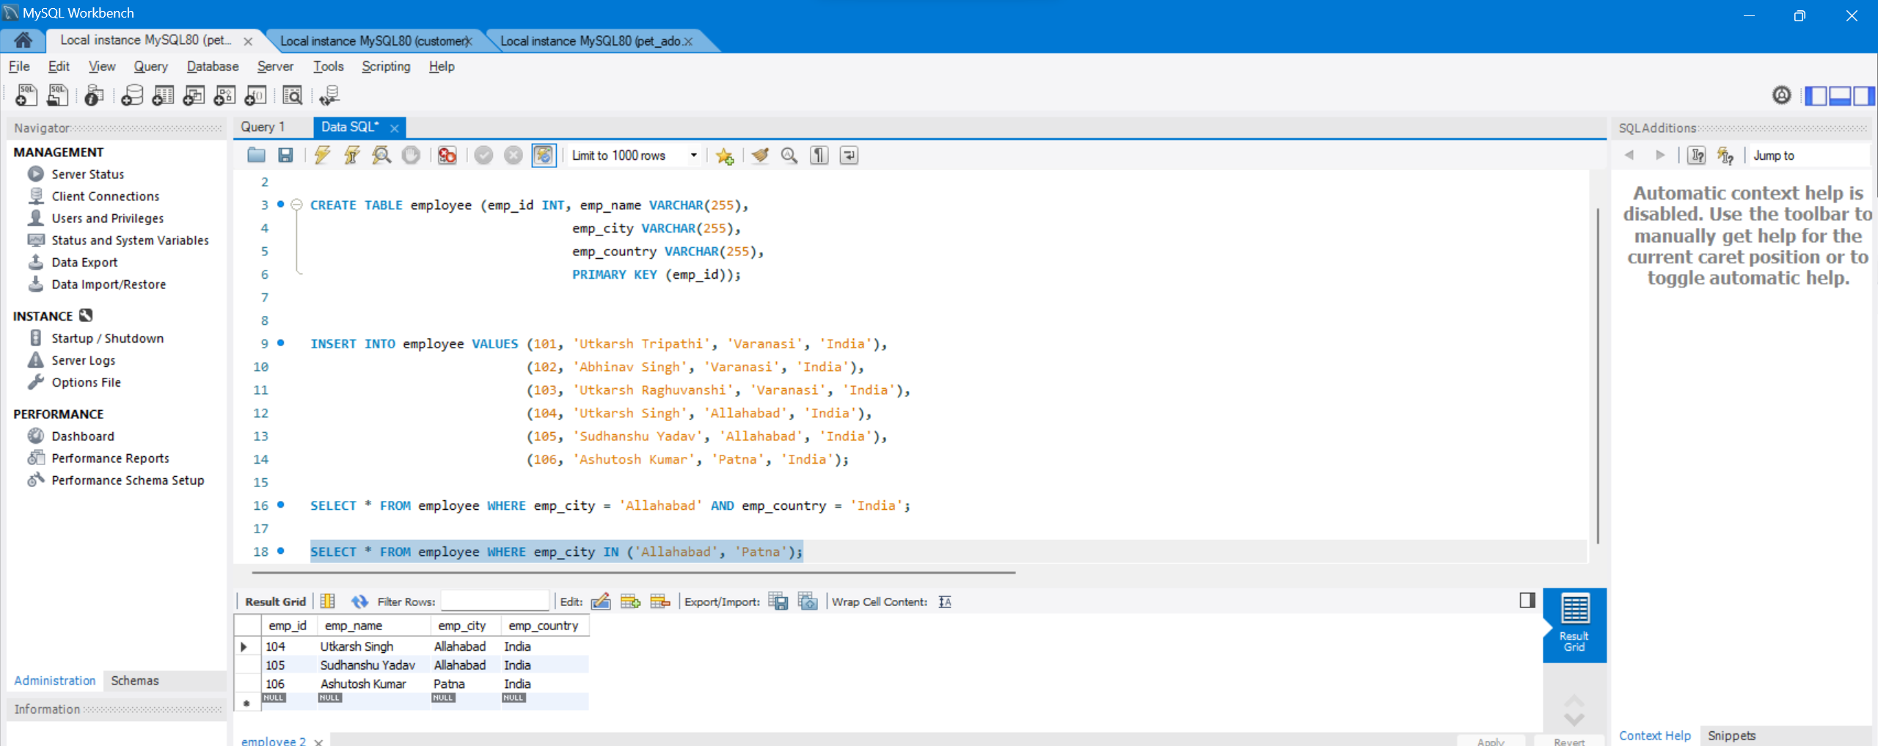

*output*

## ****NOT Operator****

### ****Query****

SELECT * FROM employee WHERE emp_city NOT LIKE 'A%';

### ****Output****

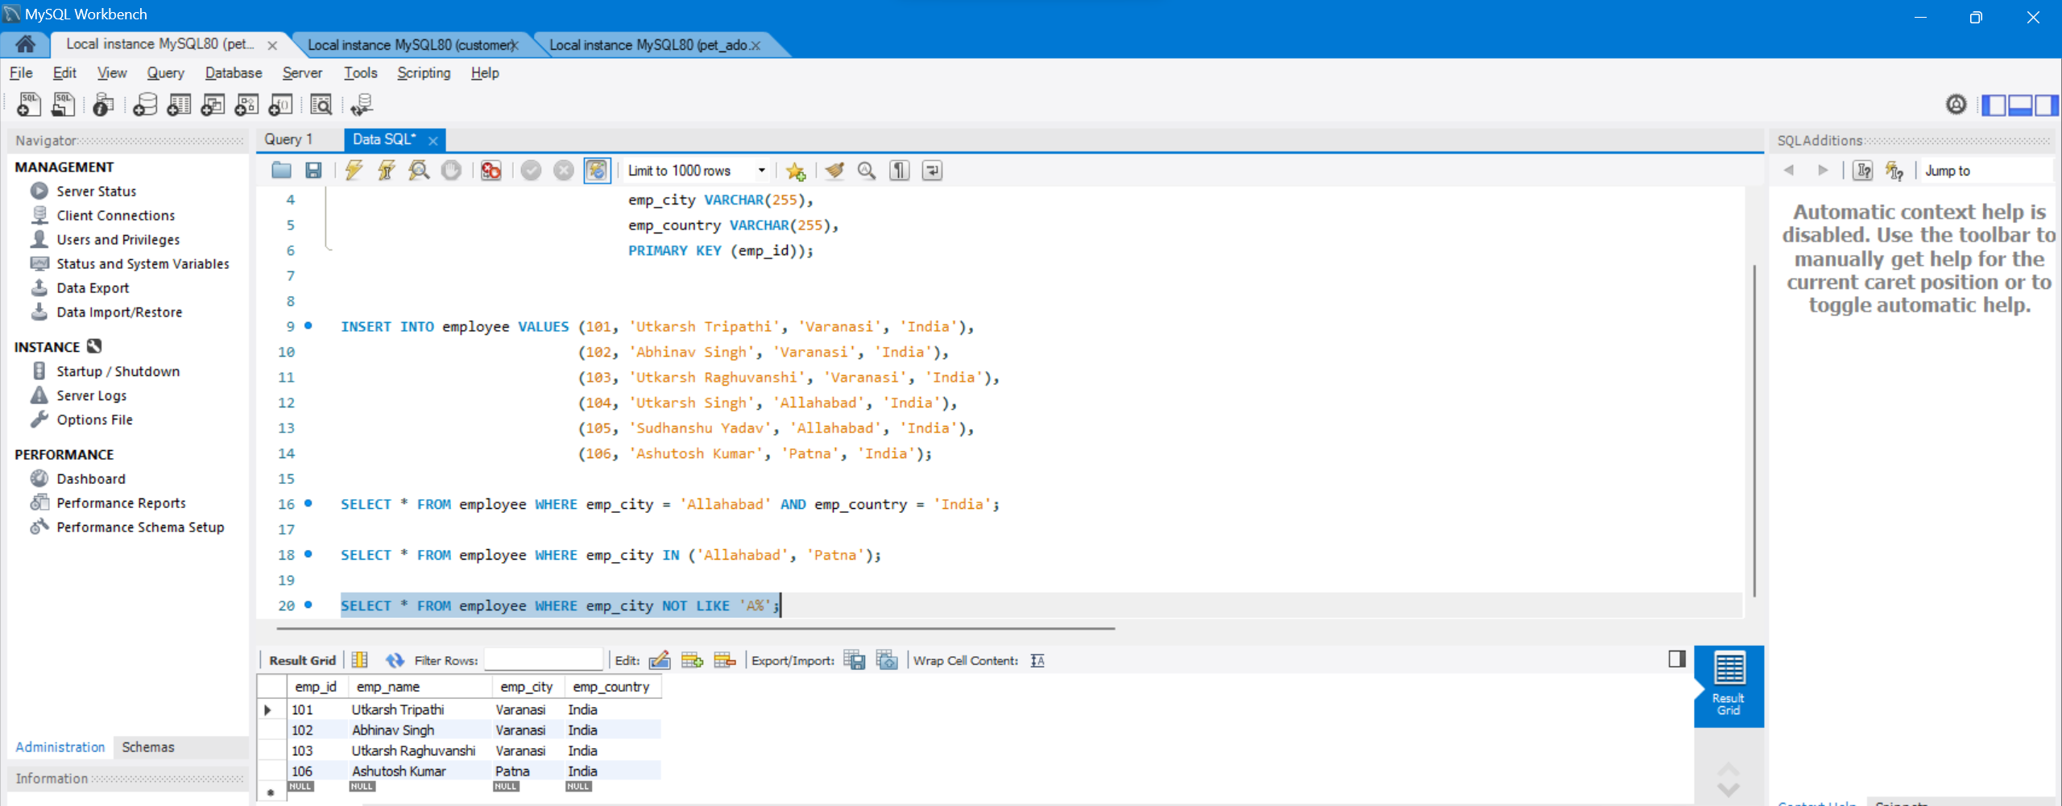

## ****OR Operator****

### ****Query****

SELECT * FROM employee WHERE emp_city = 'Varanasi' AND emp_country = 'India';

### ****Output****

### 

## ****LIKE Operator****

### ****Query****

SELECT * FROM employee WHERE emp_city LIKE 'P%';

### ****Output****

### 

## ****BETWEEN Operator****

### ****Query****

SELECT * FROM employee WHERE emp_id BETWEEN 101 AND 104;

### ****Output****

### 

*output*

## ****ANY Operator****

### ****Query****

SELECT * FROM employee WHERE emp_id = ANY  
 (SELECT emp_id FROM employee WHERE emp_city = 'Varanasi');

### ****Output****

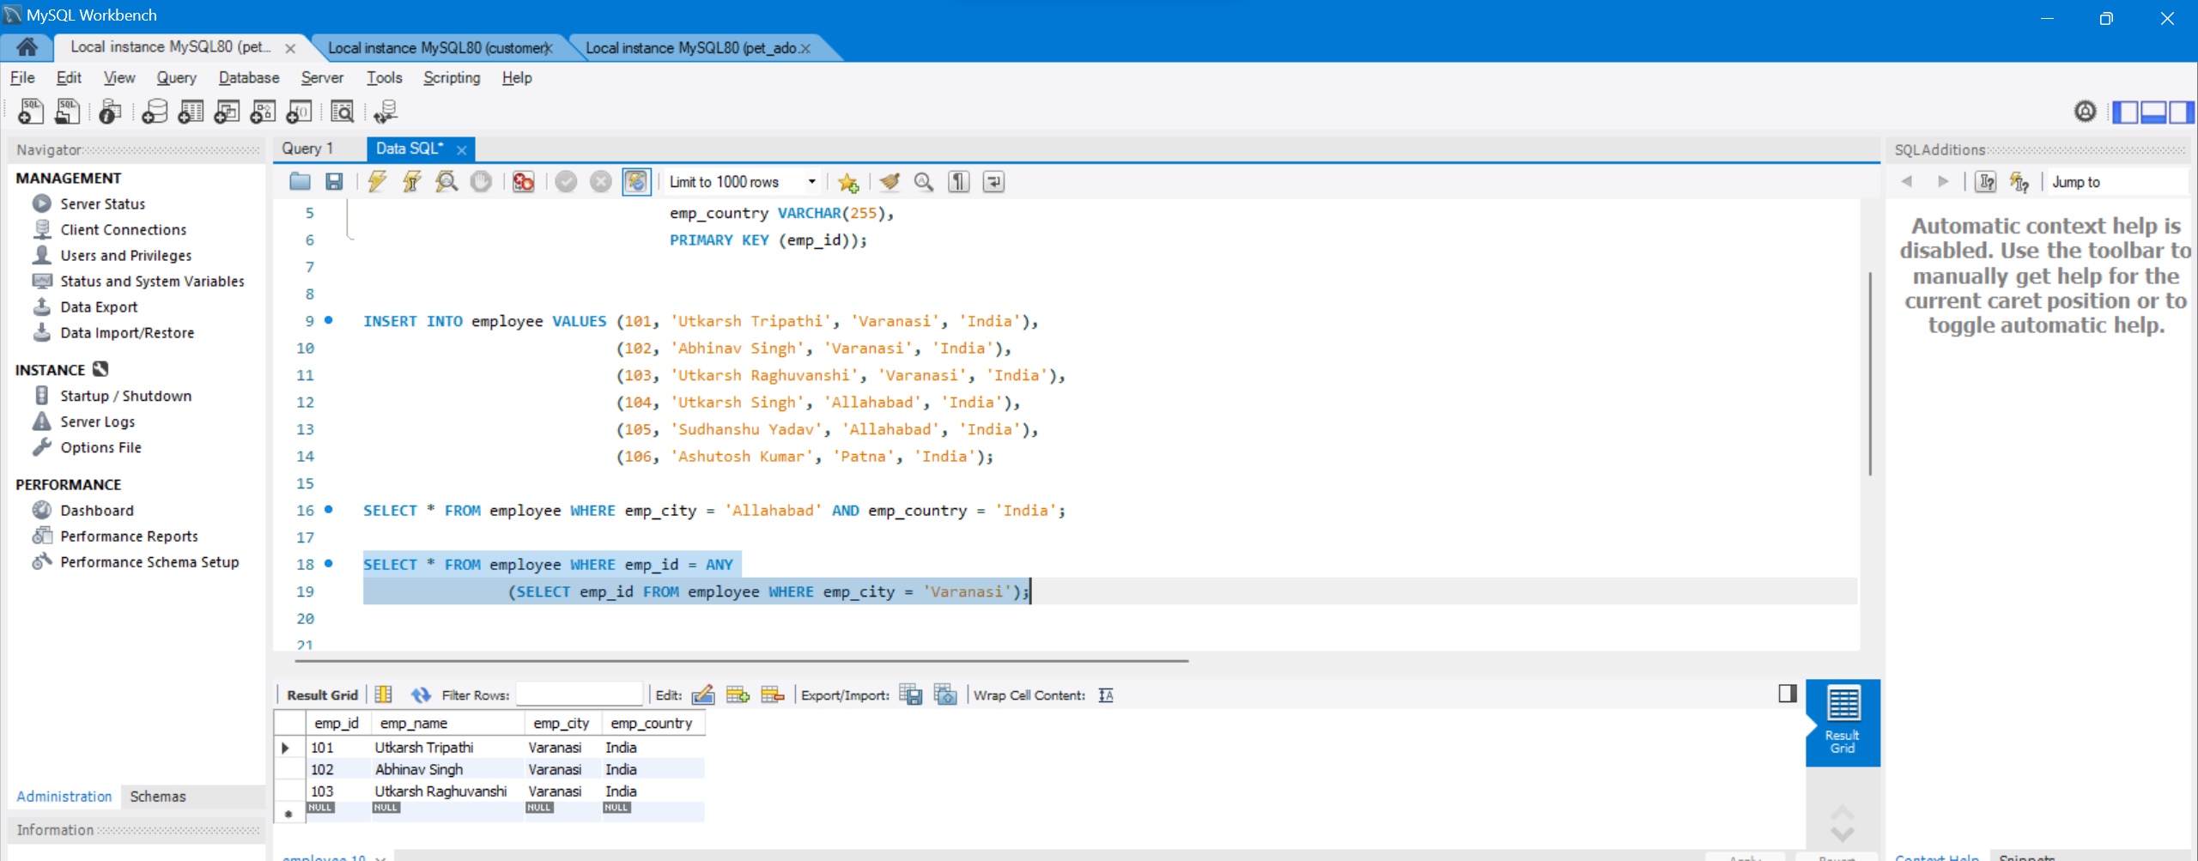

## ****EXISTS Operator****

### ****Query****

SELECT emp_name FROM employee WHERE EXISTS  
 (SELECT emp_id FROM employee WHERE emp_city = 'Patna');

### ****Output****

### 

## ****SOME Operator****

### Query

SELECT * FROM employee WHERE emp_id < SOME   
 (SELECT emp_id FROM employee WHERE emp_city = 'Patna');

### ****Output****

### 